TBC-MC3612C Series

Gigabit Fiber Media Converter Datasheet

▼Product Overview
The TBC-MC3612C Series is a 10/100/1000Mbps auto-negotiation Gigabit Fiber Media Converter equipped with one 10/100/1000Base-T auto-negotiation RJ45 electrical port and one 1000Base-X SC optical port. It supports IEEE 802.3, IEEE 802.3u, IEEE 802.3ab and other standards.The product adopts an imported low-power Marvell main chip solution from the United States and provides stable and reliable HD network signal transmission through in-house software optimization for network data transmission. Featuring a plug-in card design, these media converter cards are intended for installation in compatible 16-slot media converter chassis and supported card-type units. They provide a space-efficient and flexible solution for fiber-optic network expansion, helping integrate copper Ethernet devices with fiber-optic infrastructure in enterprise networks, campus networks, telecommunications systems, and other Ethernet connectivity applications.

▼Product Images

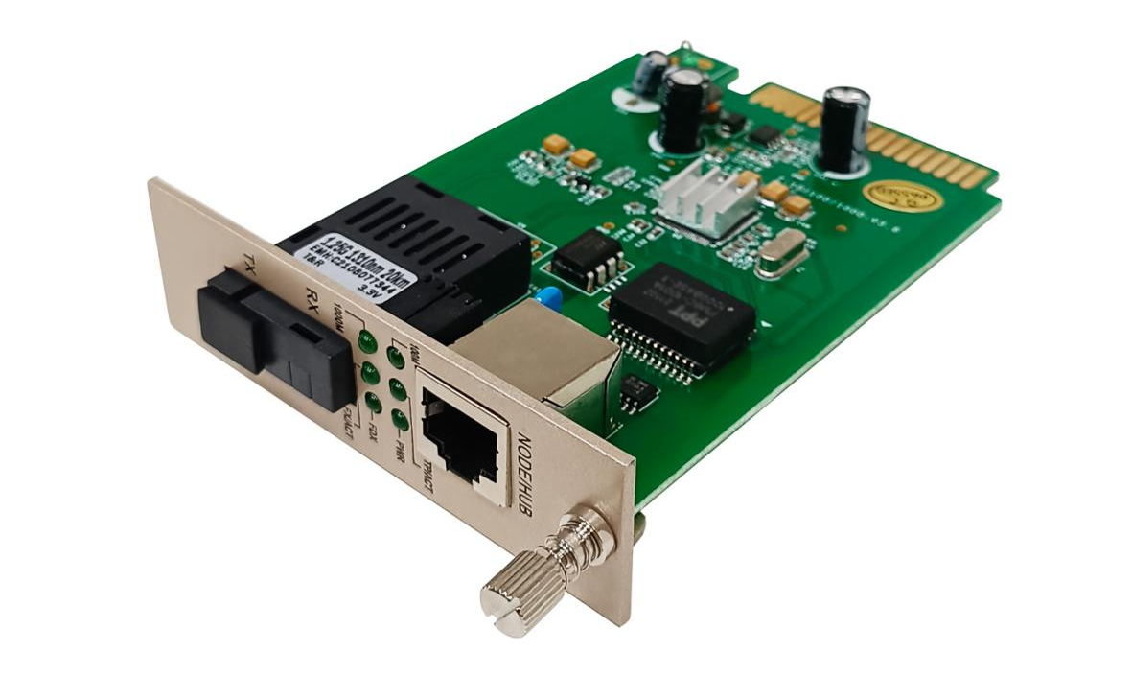

▼Product Features
- Supports 10/100/1000Mbps Ethernet auto-negotiation to accommodate different network devices and Gigabit Ethernet access requirements.
- Adopts WDM technology to enable bidirectional data transmission over a single single-mode fiber, reducing fiber deployment costs and saving fiber resources.
- Supports transmission distances of up to 180km, depending on the model and optical specifications, making it suitable for long-distance Ethernet fiber transmission.
- Supports multiple optical interface options, including SC, FC, LC, and ST, to meet different fiber connection requirements.
- Uses wavelength division multiplexing with complementary transmit and receive wavelengths, such as 1310nm/1550nm, for bidirectional transmission over a single fiber on compatible A/B models.
- Provides one 10/100/1000Base-T RJ45 electrical port and one 1000Base-X optical port for Ethernet-to-fiber and fiber-to-Ethernet signal conversion.
- Supports automatic negotiation of Ethernet port speed and duplex mode to ensure compatibility with different network devices.
- Supports automatic MDI/MDIX detection for straight-through and crossover Ethernet cables, simplifying network installation.
- Supports IEEE 802.3x full-duplex flow control to help improve data transmission stability.
- Features a plug-in card design compatible with the matching 16-slot media converter chassis and compatible card-type media converter units, enabling flexible deployment, centralized installation, and convenient maintenance.
- Suitable for centralized fiber access and long-distance network connectivity in video surveillance, enterprise networks, building networks, campus networks, FTTB, and other Ethernet fiber transmission applications.

▼Technical Specifications
Item | Specification
Product Model | TBC-MC3612C Series
Product Type | 10/100/1000Mbps Auto-Negotiation Gigabit Fiber Media Converter
Network Standards | IEEE 802.3, IEEE 802.3i, IEEE 802.3u, IEEE 802.3ab, IEEE 802.3z, IEEE 802.3x
Transmission Rate | Electrical Port: 10/100/1000Mbps;  Optical Port: 1.25Gbps
Fixed Interfaces | Electrical Port: 1 × 10/100/1000Base-T Auto-Negotiation RJ45 Port;  Optical Port: 1 × 1000Base-X Optical Port;SC, FC, LC, ST (model-dependent)
Fiber Type | Multimode dual-fiber  Single-mode dual-fiber  Single-mode single-fiber
Transmission Distance | Up to 180km, depending on the model and optical specifications
Operating Wavelength | 1310nm / 1550nm
Port Features | Supports full-duplex/half-duplex auto-negotiation and automatic MDI/MDIX on the electrical port;Supports IEEE 802.3x full-duplex flow control
Housing Material | Steel Alloy
Installation | Plug-in Card Design; Compatible with the Matching 16-Slot Media Converter Chassis and Compatible Card-Type Media Converter Units
Fiber Specifications | Multimode Fiber: 50/125μm or 62.5/125μm;  9/125μm Single-Mode Fiber (Compatible with 8.3/125μm, 8.7/125μm, and 10/125μm)
LED Indicators | 100M, 1000M, FX/ACT, TP/ACT, PWR, FDX
Power Supply | DC 5V 2A
Power Consumption | ≤5W
Operating Environment | Operating Temperature: -20°C to 65°C;  Storage Temperature: -40°C to 75°C;  Operating Humidity: 5%–90% RH, Non-Condensing;  Storage Humidity: 5%–95% RH, Non-Condensing
MTBF | >70000 Hours
Dimensions | 114 × 87 × 26mm
Weight | ≤0.4kg
Certifications | CE, FCC, RoHS
Warranty | 3 Years

▼ LED Indicator Description

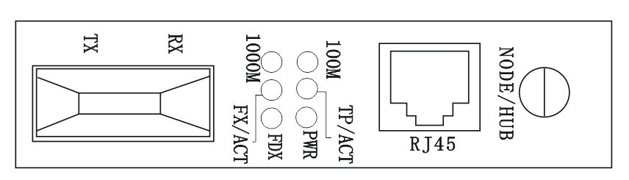
LED Indicator | Status | Description
PWR | On | Power is connected normally
100M | On | The RJ45 port is connected at 100Mbps
100M | Off | The RJ45 port is not connected at 100Mbps
1000M | On | The RJ45 port is connected at 1000Mbps
1000M | Off | The RJ45 port is not connected at 1000Mbps
TP/ACT | On | The RJ45 port link is established
TP/ACT | Flashing | The RJ45 port is transmitting or receiving data
TP/ACT | Off | No link is established on the RJ45 port
FX/ACT | On | The fiber port link is established
FX/ACT | Flashing | The fiber port is transmitting or receiving data
FX/ACT | Off | No link is established on the fiber port
FDX | On | The current port is operating in full-duplex mode
FDX | Off | The current port is operating in half-duplex mode

▼Packaging List
Packing list | Item Name | Unit | Quantity
Packing list | Gigabit Fiber Media Converter | pair | 1
Packing list | User Manual | pcs | 1

▼Ordering Information
Model | Description
TBC-MC3605C-D02 | 10/100/1000M adaptive fiber media converter: multimode, dual-fiber, transmission distance 550m, operating wavelength 1310nm, SC optical interface; modular design.
TBC-MC3602C-D20 | 10/100/1000M adaptive fiber media converter: single-mode, dual-fiber, transmission distance 20km, operating wavelength 1310nm, SC optical interface; modular design.
TBC-MC3612C-S20AB | TBC-MC3612C-S20AB: 10/100/1000M adaptive fiber media converter; single-mode, single-fiber, transmission distance 20km, operating wavelengths 1310/1550nm, SC optical interface, modular design; bidirectional transmission (1310nm at end A, 1550nm at end B; end B unit is designed for rack-mounting in a central office/server room).

